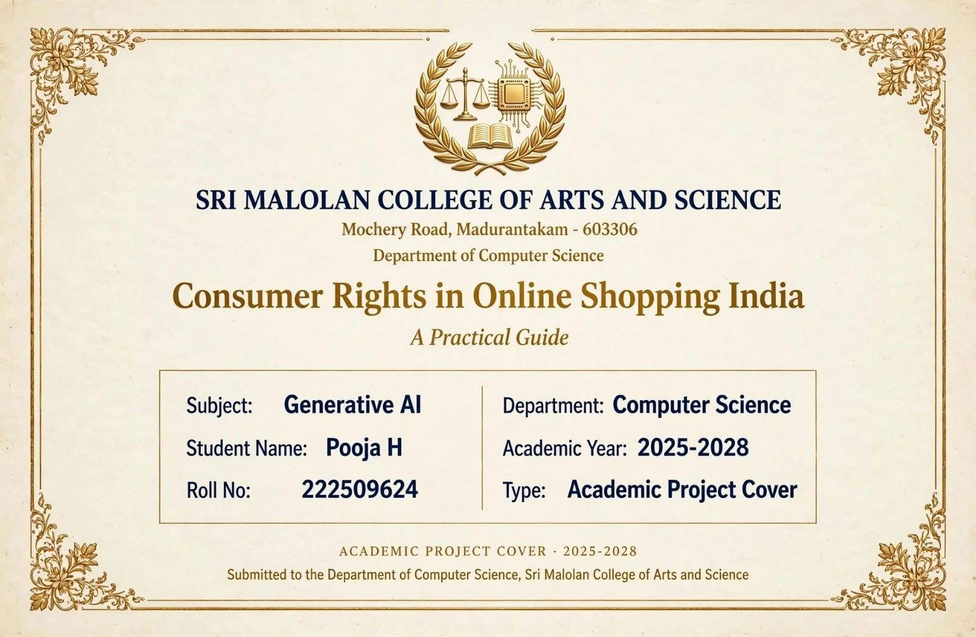

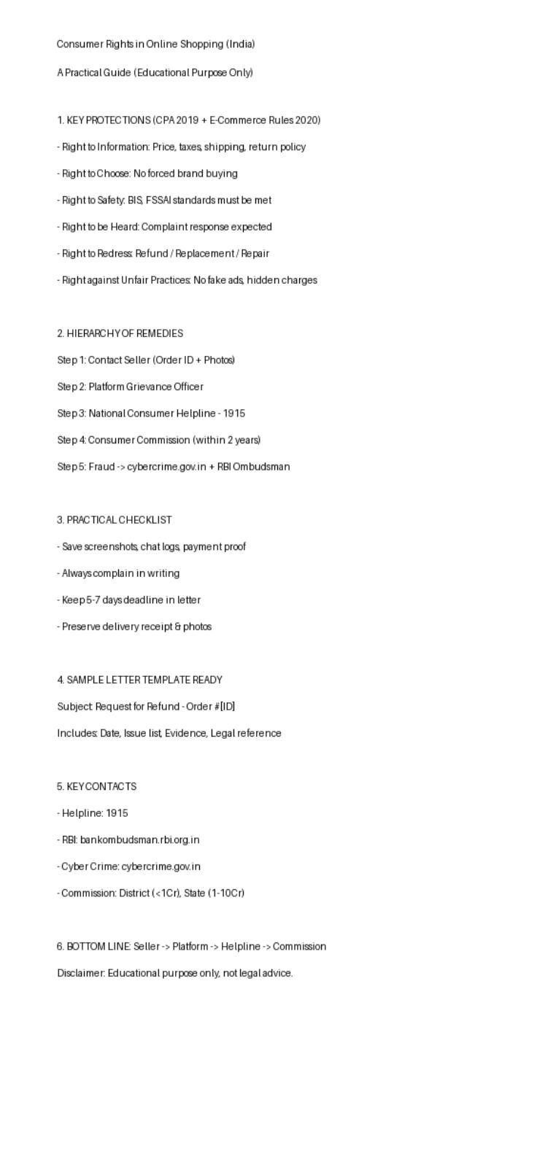

*CONCLUSION*

In the rapidly growing digital economy of India, online shopping has become an integral part of everyday life. While it offers convenience, variety and competitive pricing, it also brings challenges such as misleading advertisements, defective products, delayed deliveries and online frauds.

The *Consumer Protection Act, 2019* along with the *E-Commerce Rules, 2020* provides a strong legal framework to safeguard online consumers in India. The rights to information, safety, choice, being heard, redressal and protection against unfair trade practices ensure that consumers are not left helpless.

This practical guide shows that most consumer disputes can be resolved effectively if the proper hierarchy is followed:

*Seller → Platform Grievance Officer → National Consumer Helpline (1915) → Consumer
Disputes Redressal Commission → Cyber Crime / RBI Ombudsman*

The key to successful redressal lies in *preserving evidence* - order screenshots, payment proofs, photos and written communication. A well-drafted complaint letter within the stipulated time often leads to a quick refund, replacement or repair without needing formal legal action.

With the increasing use of *Generative AI* in e-commerce platforms, both opportunities and risks have emerged. AI can help detect fake reviews and frauds, but it can also be misused to create misleading content. Therefore, consumer awareness and digital literacy are more important than ever.

In conclusion, an informed consumer is an empowered consumer. By knowing their rights and following the correct grievance redressal procedure, every online shopper in India can ensure a safe and fair shopping experience.

➢ _This project is prepared for educational purposes as part of the Generative AI subject, Department of Computer Science, Sri Malolan College of Arts and Science._

